# POC On

# Tableau Dashboard Navigation

# Within a workbook

1)  Introduction

We have experimented the navigations between the dashboard using buttons. The buttons can be designed as tile as well as a tab. We have taken both the approaches in the POC.

For the landing page we have used the tiles page and the following content page we have used tabbed design

2)  Dashboards

We have created three different dashboards with tiles and tabs. The dashboards names as Index, 2.1 and 2.4. Index contains the list of tiles (buttons) which actually holds the navigation path for all the respective dashboards. In the same way dashboards 2.1 and 2.4 are created with buttons but it’s designed as a tabs with highlights to display the selected tab



Buttons can be dragged and used when building the dashboard. By using the button edit we can format in way how do we want design the place those buttons. In the similar way we can specify the navigation path while editing the button

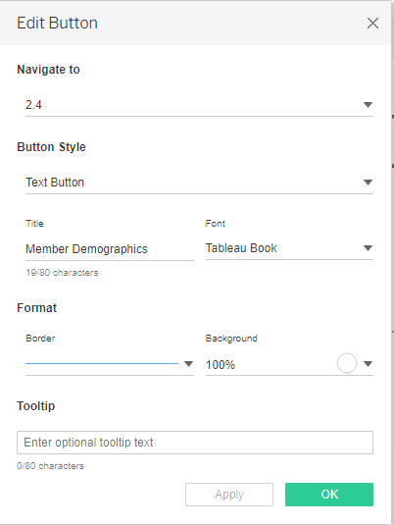

The sample dashboards and the navigation given below, the launch pad link from 2.1 and 2.4 will take us back to the index screen.

**1) Dashboard-1 (Index)**

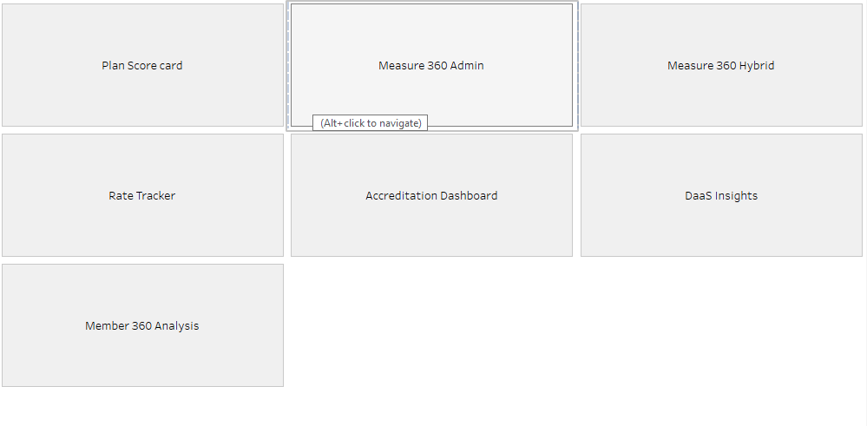

**2) Dashboard-2 (2.1)**

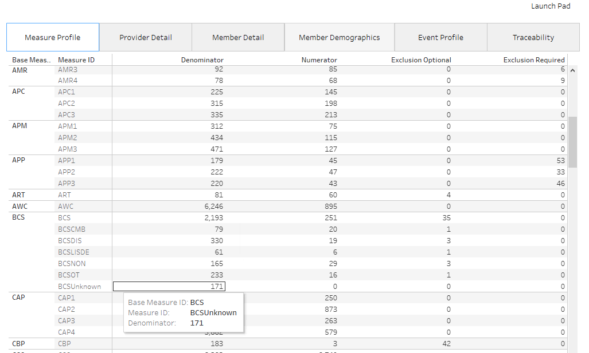

**2) Dashboard-3(2.4)**

